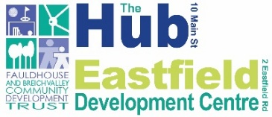

Fauldhouse and Breich Valley Community Development Trust
Communities Community Benefit Fund for the Fauldhouse and Breich Valley
Small Grant Monitoring Report 2026/27

Organisation Name

Project Title

Contact Details
Contact Name
Address

Tel
Email

Monitoring report period

Please complete the following sections.

1. How have you spent your grant?

Item of expenditure | Grant requested | Actual spend

TOTAL

Please provide a copy of all invoices/receipts for items over £100 and a copy of all bank statements covering the monitoring period.

2. Description of activities

Please provide a description of the activities your project has undertaken. Please highlight the difference the project has made to individuals, families and/or the wider community. Please add any photos you may have of your project/ activities.

3. Additional information

Please highlight any additional information or achievements that your project has accomplished.

4. Declaration

I can confirm that the details contained within the report are correct and that to the best of my knowledge all terms and conditions of the Small Grant Award have been complied with.
Name
Position
Organisation
Date

Please return to

F&BV CDT
Small Grants
The Hub
10 Main Street
Fauldhouse
West Lothian
EH47 9HX

Tel: 01501 773 699
email: smallgrants@fauldhouse.org.uk



